**AIM:-** Design a LDR interface which acts an automatic night lamp.

**Circuit Diagram:-**

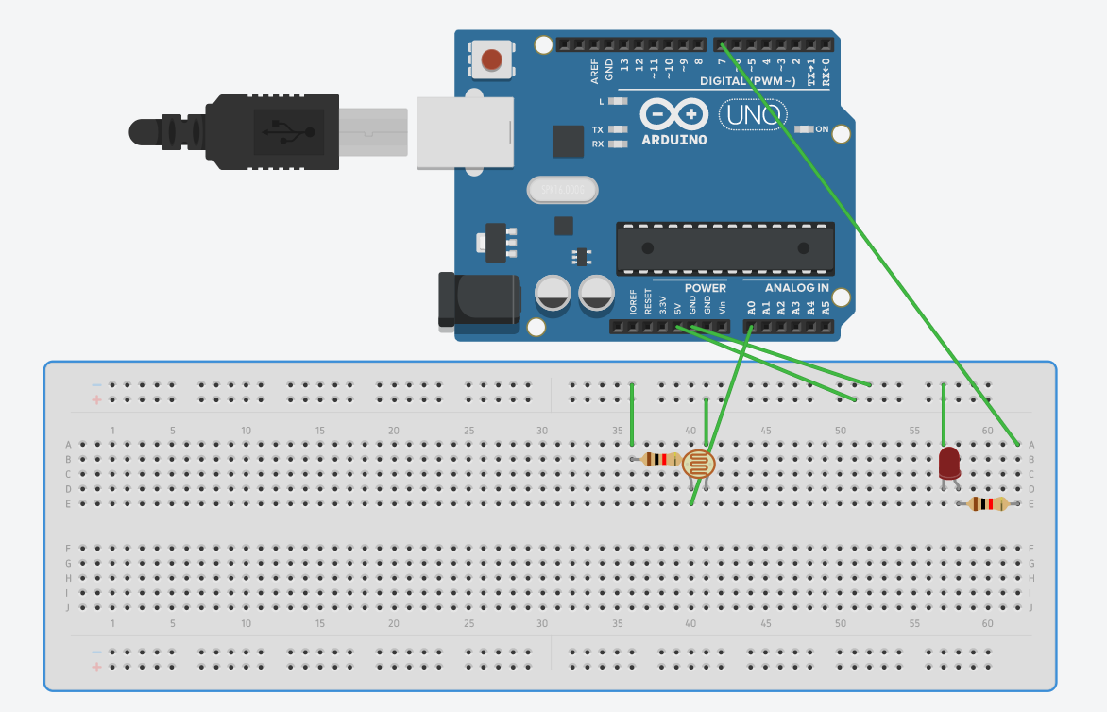

**Concepts used:-**

1.A light dependent resistor (LDR) or a photoresistor is a device whose resistivity is a function of the incident electromagnetic radiation.

2. The arduino board can supply a power of 5V as digital output signals through 14 pins present in it as digital input or output pins.

3. LED which glows whenever LDR switches resistor to least resistance

**Learning and observations:-**

1.I learnt about different components in an Arduino.

2.The basic importance of Arduino was known.

3.I also learnt the function of LDR in sensing electromagnetic radiation

**Observations:-**

When we pass electrical signals to the Arduino through our code, the LED glows when no light falls over the LDR

**Sources of error:-**

1.The connecting wires may not be connected properly.

2.There may be some error in writing program.

3. Wrong attachment of wires in terminals of breadboard.

**Precautions:-**

1.Attach the USB cable and connecting wires carefully.

2.Once the USB cable has been inserted then the Arduino connected to the USB cable should not be touched with bare hands.

**Learning outcomes:-**

1.I learnt how to make connections using breadboard and Arduino.

2.I learnt how to use LDR and connect it with LED, making it act as a night lamp which glows when no light falls over the LDR